

Course program
AOTrauma Course—Basic Principles of Fracture Management

May 31 – June 01, 2014 Tbilisi, Georgia
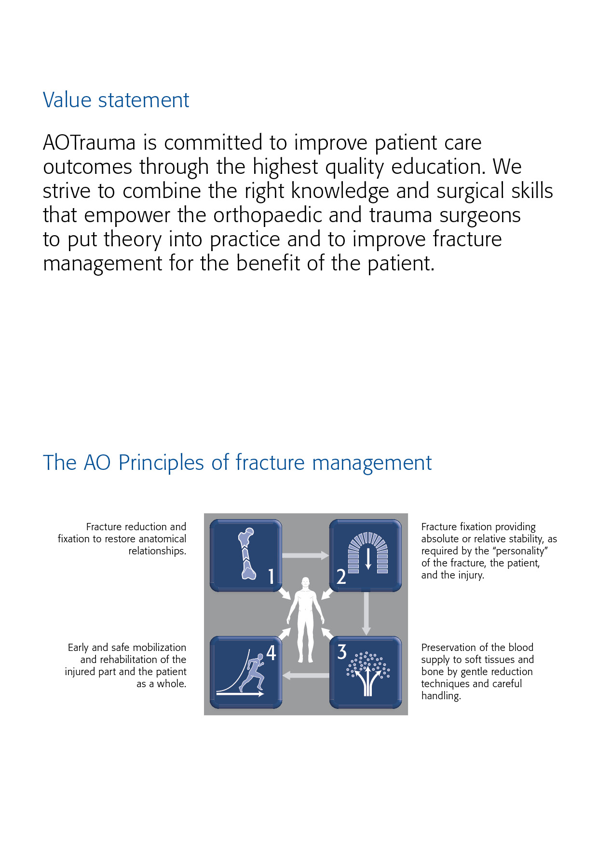

Dear AOTrauma course participant
We have the honor to welcome you to the AOTrauma Sub Regional Course—Basic Principles of Fracture Management run by the new AOTrauma Specialty! We hope you will enjoy your course and the entire experience.

What is AOTrauma? We are the "clinical division"—a community for Trauma and Orthopaedics within the AO Foundation. As an AO Specialty we aim to integrate and align applied and clinical research, education, and community development functions into one direction—AOTrauma for the benefit of our members, stakeholders, and patients.

How AOTrauma benefits you? By working as a single team we will focus and better leverage our resources, expertise, and skills to create and deliver new and greater value to our members.

What does this mean in education? AOTrauma is committed to providing you the best possible educational experience by continuously embracing and introducing new educational techniques to help you learn and more effectively implement your knowledge for the benefit of your patients.

Why join AOTrauma? Joining AOTrauma means you are part of the “Trauma & Orthopaedic” community within the AO. AOTrauma will help you develop lifelong friendships and relationships; we will help you access our “knowledge network” and get involved in new opportunities that advance trauma care.

Yours sincerely,


Kodi Kojima
Chairperson AOTrauma
Education Commission


Nikolaus Renner
Chairperson AOTrauma
International Board

PS: Your experiences with us, over the next few days, will result in the realization of new and meaningful knowledge, skills, and understanding that we hope will translate into improved patient care.

The first AO Course was held in Davos in 1960—these early courses pioneered psychomotor techniques by teaching practical skills of AO Techniques. Since those early days over 250,000 surgeons and 135,000 ORP staff from over 110 countries have attended AO Courses—we now launch AOTrauma to move our education to the next level.

Content
2 Value statement
2 The AO principles
3 Dear AOTrauma course participant
4 Goal of the course
4 Target participants
4 Course objectives
4 Course description
5 Chairpersons
5 Faculty
6 Thursday, May 29, 2014
7 Friday, May 30, 2014
8 Saturday, May 31, 2014
9 Sunday, June 01, 2014
10 Course organization
11 Course information
12 Course logistics
13 Course venue
14 Upcoming courses

Goal of the course
The AOTrauma Course—Basic Principles of Fracture Management teaches fundamental principles and current concepts in the treatment of injuries, incorporating the latest techniques in operative fracture management. The AOTrauma Basic Principles course is the initial step along the path of lifelong learning in the area of operative fracture management.

Target participants
The AOTrauma Course—Basic Principles of Fracture Management is targeted at doctors in surgical training but is also open for those who are interested in furthering their knowledge and skills in operative fracture care.
Course objectives
Discuss the concepts of stability, their influence on bone healing, and how to apply implants to achieve appropriate stability
- Plan a treatment based on assessment, imaging, classification, and decision making
- Apply reduction techniques in fracture management with attention to the importance of the soft-tissue
- Treat diaphyseal and simple (peri)articular fractures using different application techniques
- Evaluate and recognize the special problems related to; fractures in the immature skeleton, pelvic injuries, osteoporotic fractures, postoperative infection and delayed union and/or nonunion
- Plan the initial treatment of the polytraumatized patient

Course description
This face-to-face course is built in a modular system. Evidence-based lectures will cover the key information required. In the simulations of the AO Skills Lab participants will experience and test basic principles and develop important skills. Discussing cases in small groups will reinforce the principles and help participants to understand decision making and management skills. In practical exercises, participants will acquire the skills for the application of various techniques.

Chairpersons


Paata Gudushauri, Tbilisi, Georgia Aivar Pintsaar, Tartu, Estonia

Faculty
Surname FirstName, City, Country
Surnamexxxxxx FirstNamexxx, Cityxxxxx, Countryxxxxxx
Surnamexxx FirstNamexxx, Cityxxxxxxxxxx, Countryxxxxxxxx
Surnamexx FirstNamexxx, Cityxxxxxxxx, Countryxxxxxxxx
Surnamexxx FirstNamexxx, Cityxxxxxxxxx, Countryxxxxxxxx
Surnamexxxxx FirstNamexxx, Cityxxxxxxx, Countryxxxxxxxx
Surnamexxxxxxxxx FirstNamexxx, Cityxxxxxxxxxx, Countryxxxxxxxx
Surnamexxx FirstNamexxx, Cityxxxx, Countryxxxxxx
Surnamexxx FirstNamexxx, Cityxxxxxxxxxx, Countryxxxxxxxx
Surnamexxxxxxxxxx FirstNamexxx, Cityxxxxxxxxxxxxx, Countryxxxxxxxx

Thursday, May 29, 2014
Lecture hall: xxx
Time | Agenda item | Who
08:00–08:30 | Registration of participants
08:30–08:40 | Welcome and organization of the course
08:40–09:00 | The AO World - From history to life long learning
Module 1 | Injury pattern (soft and hard tissue) and the biology of bone  At the end of this module, participants will be able to:  - Outline the AO Principles of fracture management  - Explain the biology of fracture healing and how it is affected by fracture treatment  - Describe the importance of soft tissues in fracture healing  - Use the AO Classification to describe a fracture  Define absolute and relative stability and describe their effect on fracture healing | Moderator: FirstNamexx Surnamexxxx
09:00–09:20 | Bone as a living tissue – structure and function | FirstNamexx Surname
09:20–09:40 | The soft-tissue injury – soft tissue is bone bed | FirstNamexx Surnamexxxx
09:40–09:55 | Biology of bone healing why it heals and why not | FirstNamexx Surnamexx
09:55–10:10 | Müller AO Classification of Fractures – Long Bones – why | FirstNamexx Surname
10:10–10:20 | COFFEE BREAK
Module 2 | Stability and biomechanics  At the end of this module, participants will be able to:  - Describe how stability affects bone healing  - Distinguish between absolute and relative stability  - Describe the types and purposes of surgical screws and their design considerations  - Explain the principles and steps of the lag screw technique  Understand the concept of the locking internal fixator | Moderator: FirstNamexxx Surnamexx
10:20–10:40 | Absolute stability: Biomechanics, Techniques and fracture healing | FirstNamexx Surname
10:40–11:00 | Relative stability: Biomechanics, Techniques and fracture healing | FirstNamexx Surname
11:00–11:05 | LOCATION CHANGE TO AO SKILLS LAB
11:05–13:05 | AO Skills Lab  Note: at each station for 10 minutes, then rotate  - Torque measurement of bone screws  - Soft-tissue penetration during drilling  - Heat generation during drilling  - Mechanics of bone fractures  - Fracture healing  - Techniques of reduction  - Mechanics of intramedullary fixation  - Mechanics of plate fixation, part 1  - Mechanics of plate fixation, part 2  - Damaged implant removal  LOCATION XXXX | FirstNamexx Surnamexxxx
13:05–14:30 | LUNCH BREAK
14:30–15:35 | Practical exercise 1  Internal fixation with screws and plates—absolute stability  LOCATION XXXX | FirstNamexx Surname
15:35–15:40 | LOCATION CHANGE TO LECTURE HALL
15:40–16:00 | Fracture fixation using Locking compression plate (LCP) | FirstNamexx Surname
16:00–16:05 | LOCATION CHANGE TO PRACTICAL EXERCISE
16:05–17:35 | Practical exercise 2  Principle of the internal fixator using the LCP  LOCATION XXXX | FirstNamexx Surname
17:35–17:55 | COFFEE BREAK
17:55–19:00 | Discussion group 1  General principles, classification, concepts of stability, their influence on bone healing and how to apply implants to achieve appropriate stability  LOCATION XXXX  Group 1  Group 2  Group 3  Group 4 | FirstNamexx Surname  FirstNamexx Surname  FirstNamexx Surname  FirstNamexx Surname

Friday, May 30, 2014
Lecture hall: xxx
Time | Agenda item | Who
Module 3 | Surgical treatment of diaphyseal fractures  At the end of this module, participants will be able to:  - Describe the treatment goals for diaphyseal fractures  - Determine the type of reduction and stability needed for diaphyseal fractures  - Prioritize the soft-tissue injury in relation to the “personality of the fracture” | Moderator: FirstNamexx Surname
08:30–08:50 | Principles of diaphyseal fracture management—what is important in treating these fractures? | FirstNamexx Surname
08:50–09:10 | External fixator – is it useful in fracture management? | FirstNamexx Surname
09:10–09:30 | Intramedullary nailing—to ream or not to ream | FirstNamexx Surname
09:30–09:45 | Fractures of the humeral diaphysis | FirstNamexx Surname
09:45–10:00 | Fractures of the femoral diaphysis (including subtrochanteric fractures) | FirstNamexx Surname
10:00–10:15 | Fractures of the tibial diaphysis | FirstNamexx Surname
10:15–10:30 | COFFEE BREAK
10:35–11:35 | Practical exercise 3  Tibial fractures—intramedullary nailing with the expert tibial nail (ETN) (with reaming)  LOCATION XXXX | FirstNamexx Surname
11:35–11:40 | LOCATION CHANGE TO DISCUSSION GROUP
11:40–12:40 | Discussion group 2  Diaphyseal fractures—management principles  LOCATION XXXX  Group 1  Group 2  Group 3  Group 4 | FirstNamexx Surname FirstNamexx Surname  FirstNamexx Surname FirstNamexx Surname FirstNamexx Surname
12:40–14:00 | Lunch Break
14:00–15:00 | Practical exercise 4  Tibial fractures treated with different external fixator frame constructs—assessment of stability  LOCATION XXXX | FirstNamexx Surname
15:00–15:05 | LOCATION CHANGE TO LECTURE HALL
Module 4 | Preoperative planning and forearm fractures  At the end of this module, participants will be able to:  - Explain the rationale behind preoperative planning  - Recognize the importance of careful decision making with regard to reduction technique, implant requirements, and fixation techniques  - Describe a logical sequence of planning steps  - Understand the special relationship of the radius and ulna | Moderator: FirstNamexx Surname
15:05–15:20 | Forearm fractures—not just another shaft fracture | FirstNamexx Surname
15:20–15:35 | Preoperative planning—rationale and how to do it | FirstNamexx Surname
15:35–16:35 | Practical exercise 5 (part 1)  Preoperative planning—plan your forearm operation  LOCATION (in lecture room) | FirstNamexx Surname
16:35–16:55 | COFFEE BREAK
16:55–18:10 | Practical exercise 5 (part 2)  Operate your plan—fixation of a type 22-C1 forearm fracture using the 8-hole and 11-hole LCP 3.5  LOCATION XXXX | FirstNamexx Surname
19:00 | COURSE BANQUET

Saturday, May 31, 2014
Lecture hall: xxx
Time | Agenda item | Who
Module 5 | Management of articular fractures of the upper extremities  At the end of this module, participants will be able to:  - Describe the treatment goals for articular fractures  - Determine the type of reduction and stability needed for articular fractures  - Outline the function and clinical indications for the tension band technique  - Apply key surgical principles to the management of articular fractures | Moderator:FirstNamexx Surname
08:30–08:50 | Management principles for articular fractures—how do they differ from diaphyseal fractures? | FirstNamexx Surname
08:50–09:05 | Proximal humeral fractures—an update on treatment protocols | FirstNamexx Surname
09:50–09:20 | Fractures of the clavicula | FirstNamexx Surname
09:20–09:35 | Fractures of the olecranon and patella | FirstNamexx Surname
09:35–09:50 | Distal radial fractures—which to fix? How to fix? | FirstNamexx Surname
09:50–10:10 | Coffee Break
10:10–10:50 | Practical exercise 6  Tension band wiring of the olecranon  LOCATION XXXX | FirstNamexx Surname
10:50–10:55 | LOCATION CHANGE TO LECTURE HALL
Module 6 | Management of articular fractures of the lower extremities  At the end of this module, participants will be able to:  - Describe the anatomy, physiology, and response to injury of articular segments  - Recognize the need for anatomical reduction of the  joint  - Name the reduction techniques and explain when  direct and indirect methods are used | Moderator: FirstNamexx Surname
10:55–11:10 | Femoral neck fractures | FirstNamexx Surname
11:10–11:25 | Trochanteric fractures | FirstNamexx Surname
11:25–11:40 | Distal femoral fractures—management principles | FirstNamexx Surname
11:40–11:55 | Tibial plateau fractures | FirstNamexx Surname
11:55–12:10 | Distal tibial fractures—management principles | FirstNamexx Surname
12:10–12:25 | Ankle fractures—a logical approach for their fixation | FirstNamexx Surname
12:25–13:45 | LUNCH BREAK
13:45–14:45 | Practical exercise 7  Management of a malleolar type 44-C fracture  LOCATION XXXX | FirstNamexx Surname
14:45–14:50 | LOCATION CHANGE TO LECTURE HALL
14:50–16:00 | Discussion group 3  Articular fractures—management principles  LOCATION Landwasser  Group 1  Group 2  Group 3  Group 4 | FirstNamexx Surname FirstNamexx Surname  FirstNamexx Surname FirstNamexx Surname
16:00–16:20 | Coffee Break
16:20–17:30 | Practical exercise 9  Management of a trochanteric fracture using a dynamic hip screw (DHS)  LOCATION XXXX | FirstNamexx Surname

Sunday, June 01, 2014
Lecture hall: xxx
Time | Agenda item | Who
Module 7 | Emergency management and minimally invasive osteosynthesis (MIO)  At the end of this module, participants will be able to:  - Outline the algorithm for polytrauma management  - Discuss roles of the team members  - Recognize the pathology of severe pelvic trauma and identify the reasoning behind emergency pelvic stabilization  - Outline the treatment plan and priorities for open fractures  - Describe different MIO techniques | Moderator: FirstNamexx Surname
08:30–08:45 | Treatment algorithms for the polytrauma patient | FirstNamexx Surname
08:45–09:00 | Emergency management of pelvic fractures—a critical skill that can save lives | FirstNamexx Surname
09:00–09:15 | Management of open fractures | FirstNamexx Surname
09:15–09:30 | MIO—when to use it? | FirstNamexx Surname
09:30–09:35 | LOCATION CHANGE TO PRACTICAL EXERCISE
09:35–10:45 | Practical exercise 10  Stabilization of the pelvic ring using a large external fixator  LOCATION XXXX | FirstNamexx Surname
10:45–11:00 | Coffee Break
Module 8 | Special issues and problems  At the end of this module, participants will be able to:  - Recognize the special problems related to fractures in the immature skeleton  - Describe the changes in osteoporotic bone and identify special techniques to deal with them  - Describe and understand the dangers of radiation and how to avoid them  - List the causes and factors that lead to postoperative infection  - Name factors leading to delayed union and/or malunion | Moderator: FirstNamexx Surname
11:00–11:45 | The future of fracture treatment | FirstNamexx Surname
11:45–12:00 | Fractures in the growing skeleton—how are they different? | FirstNamexx Surname
12:00–12:15 | Fixation principles in osteoporotic bone—the geriatric patient | FirstNamexx Surname
12:15–12:30 | Infection after osteosynthesis—how to diagnose and manage? | FirstNamexx Surname
12:30–12:45 | Implant removal—why, when, and how? | FirstNamexx Surname
12:45–12:55 | Closing remarks | FirstNamexx Surname

Course organization
AOTrauma
George Clay
Clavadelerstrasse 8
7270 Davos, Switzerland
Phone +41 81 414 27 25
Fax +41 81 414 22 84
Email gclay@aotrauma.org

Course logistics
Industrial Partner
SYNG Ltd
Ms Manana Gudushauri
Kekelidze 18
0179 Tbilisi, Georgia
Phone +995 77 47 87 07
Fax +995 32 252 144
Email syngeo@yahoo.com

Course information
Course fee
AOTrauma Course—Basic Principles of Fracture Management: € 500.00.
Included in the course fee are conference bag with documentation, coffee breaks, and course certificate.

Accreditation
AOTrauma Courses are accredited for continuing medical education (CME) programs. The number of credit points or hours varies from country to country. The final information and number of credit points will be distributed with the course certificate.

Evaluation guidelines
All AOTrauma courses apply the same evaluation process, either the audience response system (ARS) or paper and pencil questionnaires. This will help AOTrauma to ensure that we continue to meet your training needs. In some regions, CME accreditation is dependent on the participant’s evaluation results.

Intellectual property
Course materials, presentations, and case studies are the intellectual property of the course faculty. All rights are reserved. Check hazards and legal restrictions on www.aotrauma.org/legal.

→ Recording, photographing, or copying of lectures, practical exercises, case discussions, or any course materials is strictly forbidden. Participants violating intellectual property will be dismissed.
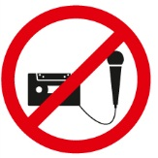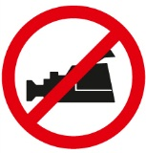
The AO Foundation reserves the right to film, photograph, and audio record during their events. Participants must understand that in this context they may appear in these recorded materials. The AO Foundation assumes participants agree that these recorded materials may be used for AO marketing and other purposes, and made available to the public.
Security
Security checks may be conducted at the entrance of the building. Wearing of a name tag is compulsory during lectures, workshops, and group discussions.

No insurance
The course organization does not take out insurance to cover any individual against accidents, thefts or other risks.

Use of mobile phones
Use of mobile phones is not allowed in the lecture halls and in other rooms during educational activities. Please be considerate of others by turning off your mobile phone.

Dress code
Casual

Course language
English

Course venue
Hotel Beaumonde Garden
Marshal Gelovani str.6a
Tbilisi, Georgia
Marshal Gelovani Street 6A, Tbilisi, Georgien
Telefon: +995 599 38 03 65
Accommodation for participants
Book your hotel room until XXXX 2014, The number of rooms is limited.
Reservation and payment will be done individually by participants.
Accomodation is not included in the Registration fee, it has to be paid directly to the Hotel.
Room rates
Twin for sgl use XXX euro. Breakfast+VAT included.
Check in at XXX p.m.
Check out until XXX of the next day.
Hotel reservation & distances
How to register???
Distances from to Hotel:
• Railway stationXXX km
• Bus stationXXX km
• Airport XXX km

Upcoming courses
Please consult the AOTrauma webpage:
https://aotrauma.aofoundation.org/Structure/education/events-courses/Pages/events-courses.aspx


AOTrauma Europe Stettbachstrasse 6, 8600 Dübendorf, Switzerland
Phone +41 44 200 24 20, Fax +41 44 200 24 21, aoteu@aotrauma.org

Logistics and support provided by an educational grant from Synthes.

